Project Documentation – FitFlex

1. Introduction

Project Title: FitFlex

Team ID: NM2025TMID44249

Team Leader:

Sri Varthini R & srivarthininkrcs@gmail.com

Team Members:

SINDHU B & sindhunkr2007@gmail.com

SHANMUGAPRIYA A & shanmugankrcs@gmail.com

NAVANEETHAM S & navaneethamnkr@gmail.com

2. Project Overview

Purpose:

FitFlex is a fitness and wellness management platform designed to help users stay motivated and consistent in their fitness journey. It enables users to track workouts, monitor diet plans, set personalized goals, and connect with trainers for guidance.

Key Features:

Personalized workout & diet plans

Progress tracking with interactive graphs

Trainer–student live chat & video sessions

Community support & fitness challenges

Admin panel for managing users and trainers

---

3. System Architecture

Frontend: React.js with Bootstrap & Material UI

Backend: Node.js with Express.js

Database: MongoDB (stores user profiles, workout logs, trainer details, and chats)

---

4. Setup Instructions

Prerequisites:

Node.js

MongoDB

Git

React.js

Express.js

Visual Studio Code

Installation Steps:

# Clone the repository

git clone <repo-link>

# Install client dependencies

cd client

npm install

# Install server dependencies

cd ../server

npm install

---

5. Folder Structure

FitFlex/

|-- client/ # React frontend

| |-- components/

| |-- pages/

|

|-- server/ # Node.js backend

| |-- routes/

| |-- models/

| |-- controllers/

---

6. Running the Application

Frontend:

cd client

npm start

Backend:

cd server

npm start

Access: http://localhost:3000

---

7. API Documentation

User:

POST /api/user/register

POST /api/user/login

Workouts:

POST /api/workout/create

GET /api/workout/:id

Trainers:

GET /api/trainers

POST /api/trainers/apply

Chats:

POST /api/chat/send

GET /api/chat/:userId

---

8. Authentication

JWT-based authentication for secure login

Role-based access control (Admin, Trainer, User)

---

9. User Interface

Landing Page

User Dashboard (Workouts, Diet, Progress Tracking)

Trainer Dashboard

Admin Panel

Integrated Chat & Video Call

---

10. Testing

Manual testing during development

Tools Used: Postman, Chrome Dev Tools

11.screenshots or demo



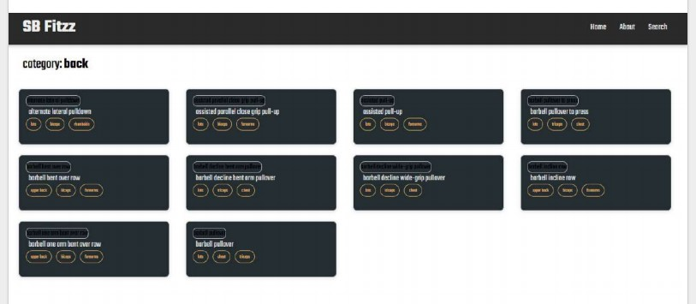

12. Known Issues

Limited offline support

Video calls may lag on low internet speeds

---

13. Future Enhancements

AI-based personalized fitness recommendations

Integration with smart wearables (Fitbit, Apple Watch)

Group fitness challenges with leaderboards

---